**КИЇВСЬКИЙ ФАХОВИЙ КОЛЕДЖ ЗВ’ЯЗКУ**

**Лабораторна робота 7**

з дисципліни «Операційні системи»

**Тема:**  
“Створення скриптових сценаріїв та визначення апаратної конфігурації

системи”

Виконали: студенти **3** курсу, групи **КСМ-13А**

**Засенко Олександр**

(прізвище та ініціали)

**Дзюбенко Дмитро**

(прізвище та ініціали)

**Сторожук Костянтин**

(прізвище та ініціали)

Київ  2023

**ЗМІСТ**

Мета роботи……………………………………………………………………...3

Завдання для попередньої підготовки………………………………………….3

Хід роботи ……………………………….……………………………………….6

Контрольні запитання…………………………….………………………..……8

Conclusions……………………………………………………………..….……..10

**Мета роботи:**

1. Отримання практичних навиків роботи з командною оболонкою Bash.

2. Знайомство знайомство з базовими діями при роботі зі скриптовими сценаріями.

**Матеріальне забезпечення занять:**

1. ЕОМ типу IBM PC.

2. ОС сімейства Windows (Windows 7).

3. Віртуальна машина – Virtual Box (Oracle).

4. Операційна система GNU/Linux – CentOS.

5. Сайт мережевої академії Cisco netacad.com та його онлайн курси по Linux

**Завдання для попередньої підготовки**

***Готував матеріал студент Zasenko***

Невеликий словник базових англійських термінів з питань призначення команд та їх параметрів.

|  |  |
| --- | --- |
| Command | Description |
| Ctrl + C | Show the current position in the file and file`s size |
| Ctrl + W | Search the document |
| Ctrl + G | Show all the commands possible |
| Ctrl + Y/V | Page up/ down |

**Пройдіть тестування у курсі NDG Linux Essentials за такими темами:**

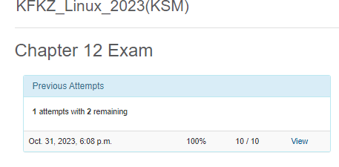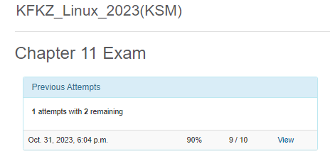

4.1. A shell script is a text file that contains a sequence of commands that are executed automatically. Scripts allow you to automate routine tasks and perform sequential operations without the need to manually enter commands on the command line.

4.2. To create and edit scripts, you can use text editors such as Vim, Nano, Emacs, or any other text editor on your system. To run a script, you need to give it execution privileges using the chmod +x script.sh command, where script.sh is the name of your script. After that, you can run the script using the command ./script.sh, where ./ indicates the current directory.

4.3. The main components of the motherboard include the processor, chipset, expansion slots, BIOS/UEFI, data and address bus, input/output (I/O) ports, memory, and sockets for processors and memory.

4.4. The concepts of MBR (Master Boot Record) and GPT (GUID Partition Table) are used to partition and format storage on devices such as hard disks and SSDs.

The MBR is used for older systems and supports a limited number of partitions (up to 4 primary partitions). It has 32-bit addressing and is limited in size to 2 TB.

GPT is a more modern standard and supports a larger number of partitions (almost unlimited) and 64-bit addressing, which allows you to work with large storages (over 2 TB) and provides reliable protection against data corruption.

4.5. The mount operation in an operating system is to connect a file system (for example, a removable device or network share) to a specific directory (mount point). This allows the operating system to access files and directories on this device or share as if they were part of the main file system. Mounting allows you to conveniently work with different data sources and provides interaction with files and directories on different devices or network shares.

**Хід роботи**

***Готував матеріал студент Dziubenko***

1. .

|  |  |
| --- | --- |
| Назва команди | Її призначення та функціональність |
| vi | file editor |
| dw | delete word |
| u | undo |
| 2wd | delete two words |
| xxxx | delete four characters |
| 4d | undo the last 4 operations |
| 14x | delete 14 characters |
| dd | delete the current line |
| p | pasted |
| J | join two lines |
| yw | copy || yank |
| P | paste || put |
| :w | save the file |
| o | open the blank |
| bash sample.sh | run bash script |
| chmod a+x | give some new rules to script |
| Cat drive.sh | Run the program |
| lscpu | CPU info |
| free | Discover how much RUM and swap space is being used |
| lspci | PCI info |
| lsusb | USB list |
| lsmod | Loaded modules |
| fdisk | List the disk devices |

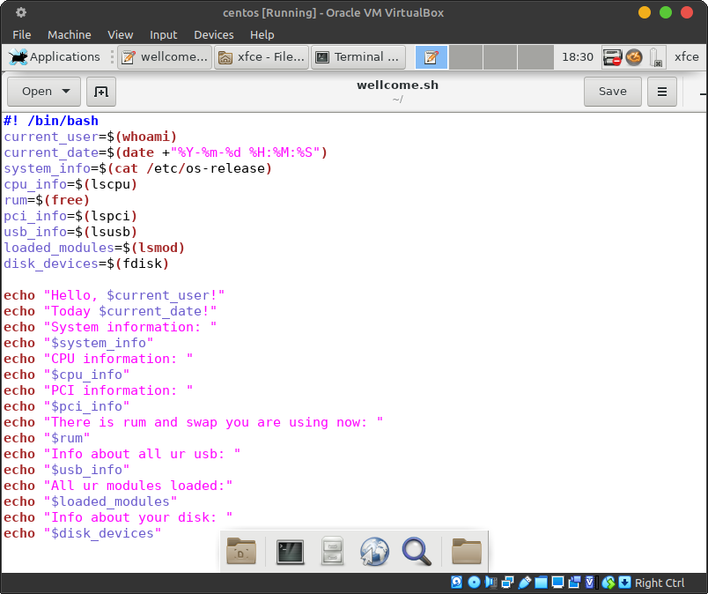

Fig 1. Display a greeting to the current user

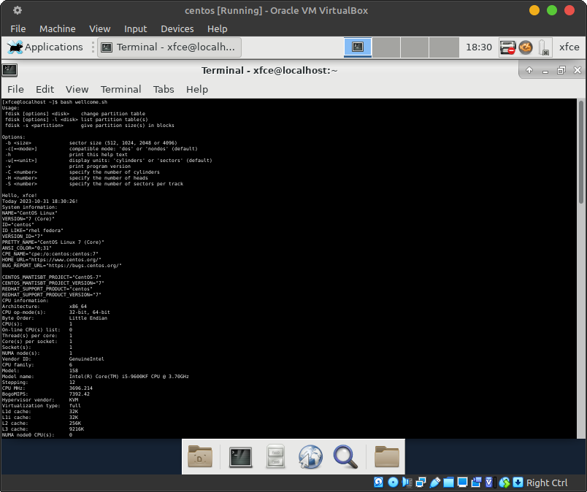

Fig 2. Display information about the hardware configuration of the current system

**Контрольні запитання**

***The material was prepared by student Storozhuk***

* In scripts, variables can be used to store data that can be used later in the script. You can assign values to variables, and you can use them in mathematical operations.

To create a variable, you can use the assignment statement.

* Branching scripts allow you to execute different blocks of code depending on the value of the variable.

To create it, you need to write an if and open the brackets in which you need to write the condition.

* Looping scripts allow you to execute a block of code many times.

To create it, you need to write for and open the brackets in which you want to write the condition.

1. The arch and lscpu commands display information about your computer's processor. However, there are several key differences between them.

The arch command displays the architecture of your computer's processor. For example, if you have an Intel x86-64 processor, the arch command will print "x86_64".

The lscpu command displays more detailed information about your computer's processor, including:

* Processor model
* Processor frequency
* Number of cores and threads
* Number of caches
* Type of memory
* Type of bus

1. You can use the free command to get information about the current system's RAM usage status. This command displays information about the total amount of RAM available, the amount of RAM in use, and the amount of free RAM.
2. In the terminal, you can use the following commands to view the connection status of peripheral devices:

* lsusb - displays a list of USB devices connected to the computer.
* lspci - displays a list of PCI devices connected to the computer.
* lsblk - displays a list of block devices connected to the computer.
* lsmod - displays a list of loaded kernel modules that can be associated with peripherals.

1. Here are some of the features of gparted:

* **Create partitions:** GParted allows you to create different types of partitions, including primary, logical, extended, protected, virtual, and so on.
* **Deleting partitions:** GParted lets you delete partitions that you no longer need.
* **Resize partitions:** GParted allows you to resize partitions to free up or allocate more space.
* **Format partitions**: GParted allows you to format partitions with different file systems, including ext2, ext3, ext4, NTFS, FAT32, and so on.
* **Clone partitions:** GParted allows you to clone partitions to create a backup or transfer data to another disk.
* **Extend partitions:** GParted allows you to expand partitions using unused disk space.
* **Create a bootable partition:** GParted allows you to create bootable partitions for different operating systems.
* **Backup partitions:** GParted allows you to back up partitions to protect your data from loss.

**Conclusions**

***The material was prepared by student Storozhuk***

In this work, we gained practical skills in working with the bash shell, and we also got acquainted with the basic actions when working with scripting, namely, we learned new commands for displaying information about the computer system. No problems were encountered during the training.